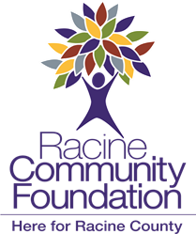
Bequest Language

Sample bequest language for your will:

To make an unrestricted gift (the use of the gift would be determined by the Racine Community Foundation):
I give the sum of $________ to the Racine Community Foundation, Inc., 1135 Warwick Way, Ste. 200, Racine, WI 53406, or its successor in interest.

To restrict the gift to a particular fund that you may or may not have funded during your lifetime (this option allows you to plan ahead by completing one of the standard fund agreements, for example, which the Racine Community Foundation would retain knowing that it would like not be funded until your death):
I give the sum of $_______ to the Racine Community Foundation, Inc., 1135 Warwick Way, Ste. 200, Racine, WI 53406, or its successor in interest, for the purpose of adding to or creating the (insert name of fund) on terms consistent with those I have left on file with the Racine Community Foundation, Inc.

Or, you may leave a percentage of your residuary estate to the Racine Community Foundation or a specific asset to the Racine Community Foundation instead of a sum of money. For example, you can name the Racine Community Foundation as a beneficiary in a life insurance policy, your IRA or 401(k). Any gifts made to the Foundation are subject to the Gift Acceptance Policy.

For more information, please contact Liz Powell, President & CEO at liz.powell@racinecommunityfoundation.org or 262.632.8474

